Week 1

1. Exercise on Page 11-13 of [Module1 BasicConcepts ppt.pdf](https://ucdenver.instructure.com/courses/456909/files/12950267?wrap=1)[Preview the document](https://ucdenver.instructure.com/courses/456909/files/12950267?wrap=1)

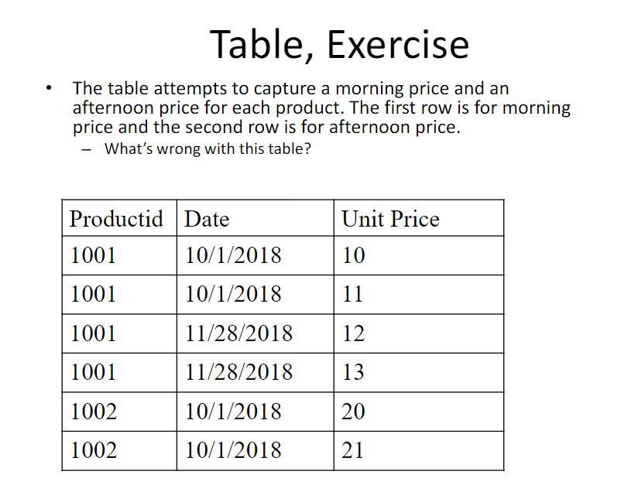

In this table there is no way to find the unique row and as there is no distinction between the unit price for morning and afternoon. As per the description of a table the order of the rows has no meaning. There is no option to have a primary key.

1. Exercise on P21, P22 of [Module1 BasicConcepts ppt.pdf](https://ucdenver.instructure.com/courses/456909/files/12950267?wrap=1)[Preview the document](https://ucdenver.instructure.com/courses/456909/files/12950267?wrap=1)

**P21**

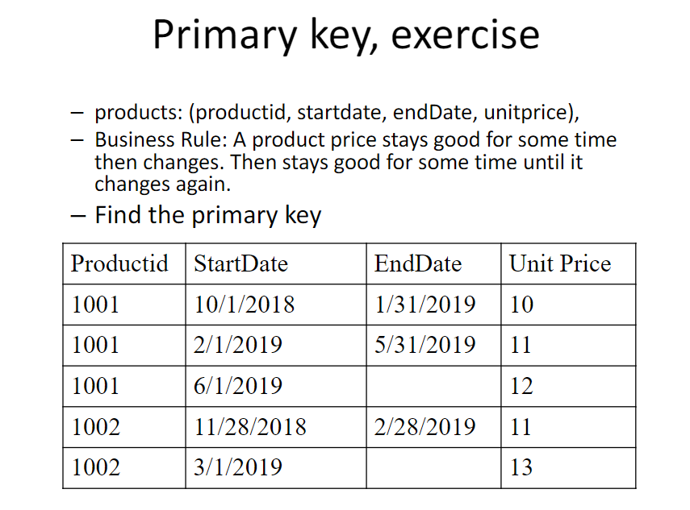

In this table, since ProductId is repeating we will use the combination of column as primary key. For a product, unit price changes for every start date. So primary key to uniquely identify the unit price data will be the combination of **ProductId + StartDate**

We will be ignoring the End date for primary key since it is nullable.

**P22**

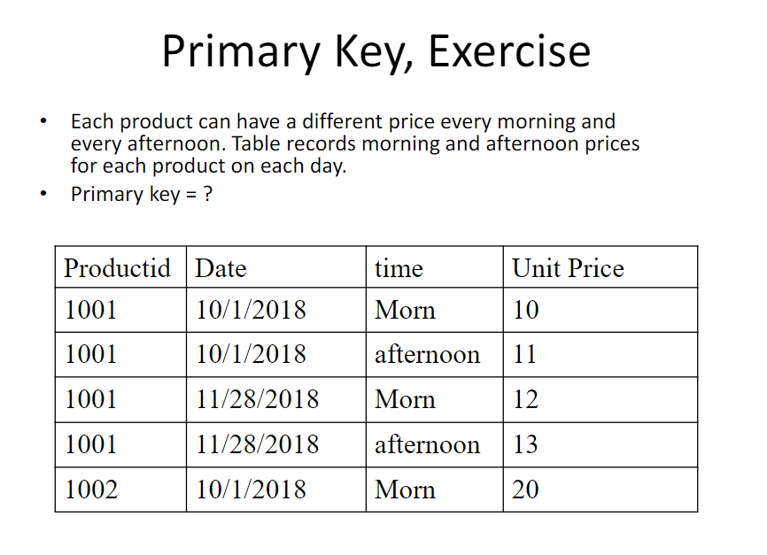

Primary key is **Productid + Date + time**

1. Problems 1 and 2 of [Module1 Exercise.pdf](https://ucdenver.instructure.com/courses/456909/files/12904350?wrap=1)[Preview the document](https://ucdenver.instructure.com/courses/456909/files/12904350?wrap=1)

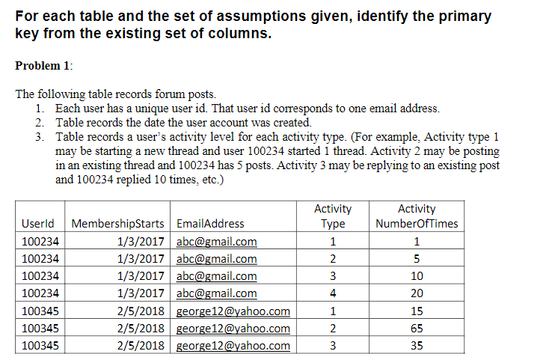

Primary Key is **UserId and Activity Type.**

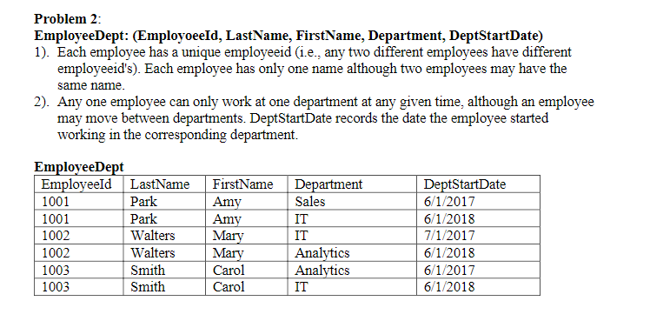.

Considering an employee can move between the department at any given time. Primary Key is **EmployeeId + DeptStartDate**